rainbow wave festival 2020

Sponsorship Proposal

Prepared for ___________________________
Prepared by Carly McDonald
Project Coordinator - Rainbow Wave Festival
Peer Worker – headspace Bega

CONTENTS

- Event History/Purpose
- Planning for 2020
- Feedback & Survey Results from 2019
- Recognition
- Sponsorship Package
- Terms & Conditions

EVENT PURPOSE
The 2019 Rainbow Wave Festival (RWF) was the Bega Valleys first Mardi Gras style event. It was held at the Oakland’s Events Centre in Pambula, attracting over 400 people.
RWF was initially set up as a day to celebrate diversity and inclusiveness for the LGBT+ community of the Far South Coast, quickly turning into something far more significant.
It became a safe space to truly be yourself and ask where to get help if struggling with issues associated with sexuality and identity for individuals as well as allies and created a sense of connection to an often-hidden community, especially in the country.
The festival is an opportunity to frock up, be fabulous, dance, listen to inspiring speakers and generally have some fun. It has kick-started conversations, reduced stigma and helped in the establishment of a number LGBT+ support groups.

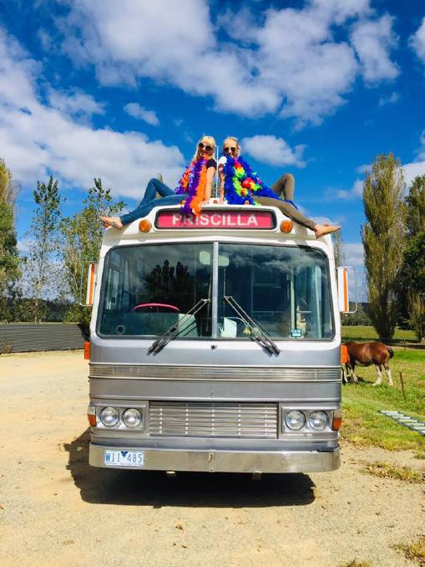
PLANNING FOR 2020
Date: 22nd Feb 2020
Location: Merimbula, NSW
Due to the community’s supportive response, next year RWF will be going public with a street parade followed by live music and performances in the Merimbula Town Centre. We would like to make this an annual event and accessible for everyone.
Confirmed Speakers & Performers:
BONUS: The Priscilla Bus will be returning…

- Bournda Rock (Local Youth Band)
- Alicia Zamann (Local Drag Artist)
- Pablo the Bearded Drag Queen MC & DJ
- Teddy Cook (ACON Speaker)
- Gabe ‘Journey’ Jones (Slam Poetry)
We are currently in the process of recruiting more artists and have been in contact with some big names.
Watch this space!
FEEDBACK
Following the 2019 festival, the RWF committee created a feedback survey. While only a small number of responses were lodged (32) the results clearly demonstrate that the event was not only enjoyable but also promoted important messages.

“It made me feel so proud that a rural town like Pambula could hold such an event and for it to be so successful”

“The event was a great celebration of rainbow. It was safe and accepting and provided an opportunity for me to show support to my 15 year old”

“I attended this event with my 2 mums. It is not very often we get to go out as a family. Now I have an even bigger family that I didn’t know even existed”

“The love and support in that one space was so heart-warming and moving. I have lived here for over 20 years and this was the first time I really felt like I belonged.”
“This has been the single best thing for my mental health. Just feel normal for a change. I’m not the one with the problem - society is.”
RAINBOW WAVE RECOGNITION
Research
Along with our attendance feedback survey, Charles Sturt University also sent a number of researchers to conduct interviews with participants about their experiences both personally and as an attendee of the event. The research has the view of helping to support other rural and remote communities to develop similar projects. The lead researcher was Dr. Clifford Lewis and the results from this research are promising.
Awards & Nominations
RWF is honoured to have won the NSW Mental Health Matters Rainbow Inclusion Award: Recognising Mental Health related programs, projects or initiatives that demonstrate commitment to the mental health and wellbeing of sex, sexuality and/or gender diverse (LGBTQIA+) people.

We also received a nomination for a NSW/ACT Regional Achievement & Community Award: Encouraging, acknowledging, and rewarding the valuable contributions individuals, communities and businesses are making throughout regional New South Wales and the ACT.
Media Coverage
RWF is grateful to have received coverage from media outlets including About Regional, 2EC Radio, Power FM Bega/Bay, Merimbula News Weekly, Bega District News & the RAMHP Glovebox Guide.

SPONSORSHIP
We have come a long way, but we still need your support. Last year’s success was owed to the kindness and generosity of the local community and of course, the donation of the Oakland’s Events Centre. This enabled us to use the funds gained from ticket sales to cover the cost of the event. Your generous contribution towards our 2020 Festival will help us extend our mission of creating a more inclusive, supportive community for our LGBTI+ youth, by bringing the Rainbow Wave Festival into the public arena.
Want to be a proud sponsor of the inaugural Rainbow Wave Festival?

GOLD
A contribution of $10,000 could assist us to:
- Have the capacity to provide financial remuneration for one of our committee members to become the official event organsier
- Hire a sound technician
- Provide Public Transport for surrounding communities to participate in the event
- Purchase Décor to decorate the Merimbula Township
- Hire Security for the event
- Provide accommodation and transport for visiting performers and speakers
- Hire PA equipment for the mainstage

SILVER
A contribution of $5,000 could assist us to:
- Hire Security for the event
- Provide Public Transport
- Hire PA equipment
BRONZE
A contribution of $1,000 could assist us to:
- Hire PA equipment

TERMS & CONDITIONS
Terms and Conditions will be drawn up between the Sponsor and the Rainbow Wave Festival coordinator when it has been confirmed which package will be provided.
Packages are flexible and can be altered by a new agreement drawn up between both parties.

Please contact Carly McDonald if your business would like to purchase a sponsorship package for the Rainbow Wave Festival 2020.

@: cmcdonald@gph.org.au
Ph: 0402 653 528

